Niko Lopez
3/11/2020

Lab 3 Report: Least Cost Paths
Introduction:
Least Cost Overland paths have been used to better determine the best routes for many types of infrastructure such as power lines, as shown in the study “Routing of power lines through least-cost path analysis and multicriteria evaluation to minimize environmental impacts” (Bagli 2011). The GIS methods in the study produced an array of possible routes by utilizing a least cost path analysis. The criteria used to produce the total cost raster consisted of impacts on human health via electromagnetic radiation, impacts on the landscape/ viewshed, and impacts on the surrounding ecosystems. The selection of criteria to be used in a total cost raster and the weights that are given to each of the criteria is a critical factor in finding suitable pathways for projects such as new roads, powerlines, or pipelines.
This lab focuses on tracking the probable migration paths of a fictional folklore creature called a Wolpertinger. The objective of this lab is to build a cost raster and run a least cost path analysis on the raster to determine the probable migration path.

Methods:
The primary analysis done in this lab is the least cost path analysis, which is run on a total cost raster layer, compiling the costs on multiple weighted criteria. The total cost raster determines the probability that a Wolpertinger may be sighted at any given point within the study area. The criteria are as follows; wolpertingers are most likely to be found in thickly forested, steep hillsides, with no water bodies. The cost raster was put together and then a least-cost path analysis was run based on ten points of origins “dens”, producing a shapefile with the most likely paths from each den to the town of Orick, CA.

Results:
The least cost path analysis produced the shapefile shown below in Figure 1. As you can see, each path converges on the other paths, and for the last few miles leading up to Orick every path has converged into one path.
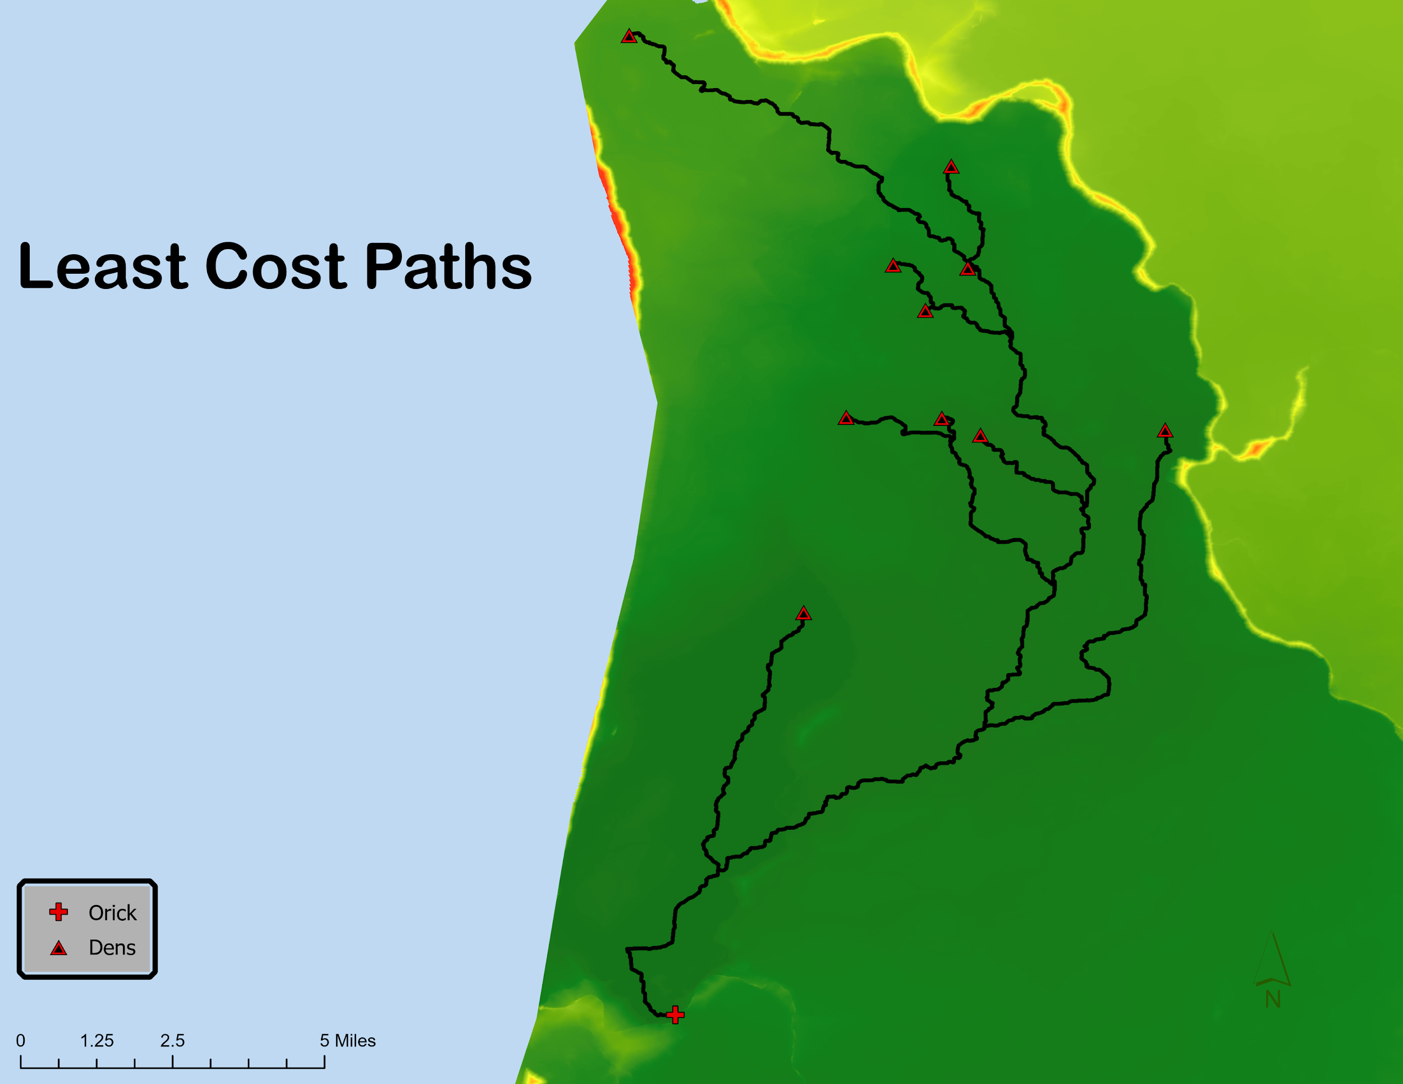
Figure 1. The ten least cost paths from each of the dens to the town of Orick.

The Overall cost of each of the paths is shown in Table 1. Obviously, the highest cost path is the longest, this path is much higher in cost because a creature traveling along it would cross through a flat area on the north end of the study area, adding a large amount of cost. The other paths are fairly similar in value however since the paths converge down to a common path quite quickly after they begin.
Table 1. The cost of each of the paths created in the analysis.
Den ID | Path Cost
A | 1757620
B | 1028470
C | 1226230
D | 1314440
E | 1257510
F | 1184760
G | 1357150
H | 1249320
I | 1163000
J | 1179860

Conclusion:
Although it is absurd to study mythical creatures, and their migration patterns based on anecdotal information, it is extremely useful to be able to compile numerous criteria and determine a least-cost path with such ease. There is an endless list of useful applications for these methods which go far beyond determining the migration patterns of mythical creatures.

Works Cited
Bagli, S., Geneletti, D., & Orsi, F. (2011). Routing of power lines through least-cost path analysis and multicriteria evaluation to minimize environmental impacts. Environmental Impact Assessment Review, 31(3), 234–239. https://doi.org/10.1016/j.eiar.2010.10.003

