Potential Restoration Goals
& Future Impact of Sea Level Rise on the Lanphere Dunes

Summer Shaw, Nikolas Lopez and Audrey Schue
5/7/2018
GSP 270

Abstract
To better understand the vegetation and the effects of sea-level rise, a small area near Lanphere dunes which is part of an ongoing restoration project, was chosen as the site of analysis. The plot is a small section of the foredunes and invasive plants have changed the ecological balance by inhibiting sand movement, crowding out native plants and preventing the federally listed Snow Plover from utilizing and nesting in this dune section. To determine the impact of sea level rise on the site, a high resolution Digital Elevation Model (DEM) was acquired and various analysis tools were used to make a risk map of the site. In addition, vegetation species composition and cover was determined via transect and quadrat method and ocular analysis. The data gathered determined the overarching goals of this restoration project: invasive species treatment to remove the dominant cover type, the grass species Ammophila arenaria and resorting the habitat to be suitable for other native flora and fauna species, especially the Snowy plover.
Intro
The plot is a small section of the foredunes, and invasive plants have changed the ecological balance by inhibiting sand movement, crowding out native plants and preventing the federally listed Snow Plover from utilizing and nesting in this dune section. Many invasive plants were first introduced to the dunes for the purpose of stabilizing the shifting sands in the early 1900’s (Science & Nature, Friends of the Dunes). The study of dune restoration first began at the Lanphere Dunes in the late 1970’s. Since then a lot has been learned about the practices of restoring dunes and how dunes react to the removal of invasive plants like the Ammophila arenaria (IPCW Plant Report). Restoration of the dunes on the North Spit in Humboldt County focuses on hand removal of non-native, invasive plant species (Dune Restoration, US Fish & Wildlife).
Even though many sections of the dunes have been restored, there are still substantial portions that have yet to be worked on. The section we will performing our analysis on has not yet been restored and data needs to be collected to understand the site condition and biological composition to determine restoration goals and projecting future impacts of sea level rise, see figure one for the site location.
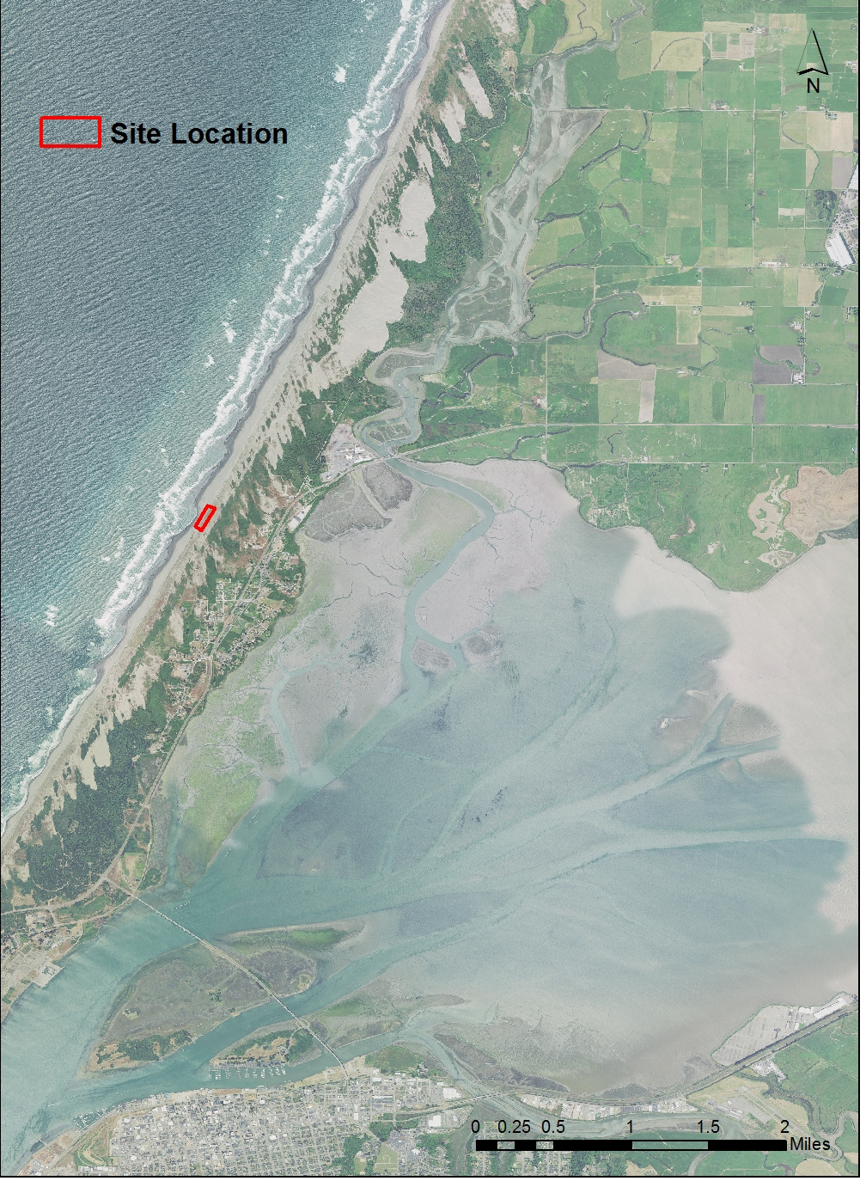
Figure 1: Site locator map, Humboldt County California.
Methods
Sea level Impact Analysis:
To determine the impact of sea level rise on the site, the following steps were taken. To begin, high resolution data was searched for and acquired online. High resolution data was necessary, due to the small size of the site. Two rasters were selected including a lidar DEM, and an aerial imagery raster. In order to understand the impacts of sea level rise on the site, the reclassify tool was used on the DEM. The raster calculator was used to determine the highest and lowest elevation of the site. The intervals for classification were selected in between the highest and lowest points. The Reclassify tool was used on the DEM, using the intervals determined in the last step. Refer to Figure 2 for a visual representation of the steps taken in determining the impacts of sea level rise on the site
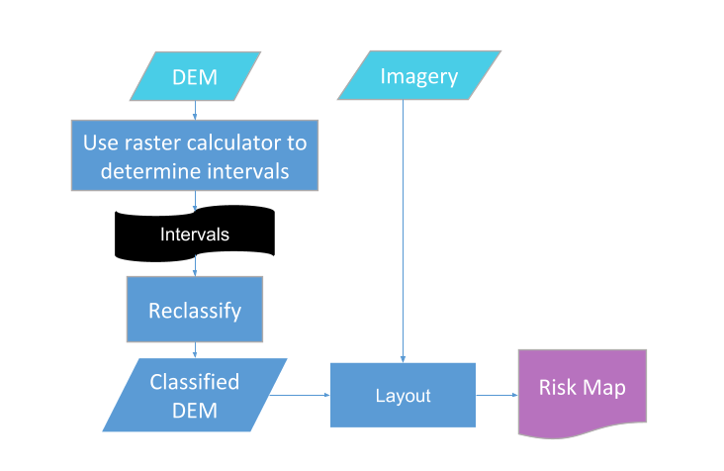
Figure 2: A flowchart, illustrating the steps taken for spatial analysis.

Vegetation Data Collection:
Vegetation species composition and cover was determined via transect and quadrat method and ocular analysis. A starting point was randomly selected, the first transect was 40 meters long, west to east with 5 quadrats placed every 7 meters (plots 1-5). The second transect was north to south, 25 meters long and a quadrat was placed every 10 meters, resulting in two quadrats placed (plots 6-7). The quadrat was 1m^2, this method was used to quantify the species composition and cover distribution in the site. Composition and cover was determined based off of 9 cover classes, refer to table 1. The results are recorded in table 2. The transects were representative of the site because the leeward, windward, crest and troughs of the dunes were documented. Overall, the species composition was lacking diversity and had very little substaight showing, the dominating cover type was Ammophila arenaria.
Table 1: Cover class breakdown.
Cover classes | Percent
1 | 1%
2 | 2-10%
3 | 11-20%
4 | 21-35%
5 | 36-50%
6 | 51-65%
7 | 66-80%
8 | 81-95%
9 | 96-100%

Table 2: Results from quadrat method.
Plot 1
Species/substrate | Cover class
Ammophila arenaria | 4
Solidago spathulata | 3
Sand | 3
Plot 2
Species/substrate | Cover class
Ammophila arenaria | 6
Lathyrus littoralis | 1
Solidago spathulata | 2
Sand | 1
Plot 3
Species/substrate | Cover class
Ammophila arenaria | 9
Sand | 1
Plot 4
Species/substrate | Cover class
Ammophila arenaria | 5
Eriogonum latifolium | 1
Armeria maritima | 2
Lathyrus littoralis | 2
Claytonia rubra | 1
Plot 5
Species/substrate | Cover class
Achillea milefolium | 2
Fragaria chiloensis | 2
Claytonia rubra | 1
Ammophila arenaria | 4
Solidago spathulata | 1
Plot 6
Species/substrate | Cover class
Achillea milefolium | 9
Sand | 1
Plot 7
Species/substrate | Cover class
Achillea millefolium | 5
Sand | 5

Results
Our analysis resulted in two maps which gave us a better understanding of how sea level rise will affect the area of the chosen plot, a small section of foredunes near the Lanphere dunes. Figure 2 shows the the different types of invasive vegetation in the area, as well as the visible differences between restored and unrestored areas of foredunes. Figure 3 shows the same area, but with an inundation map showing what areas will be affected by different levels of sea rise.

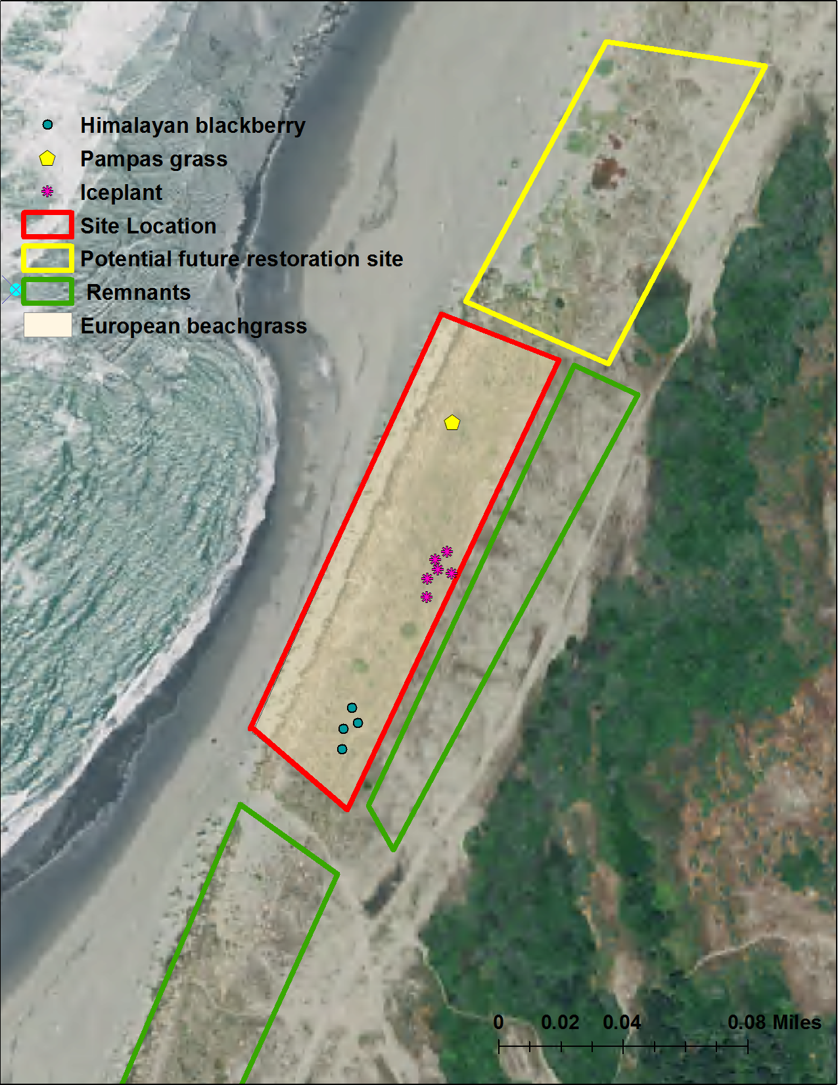
Figure 3: Site map: including current invasive species cover, restored areas (remnants) and potential area of fure expansion via ocular analysis.
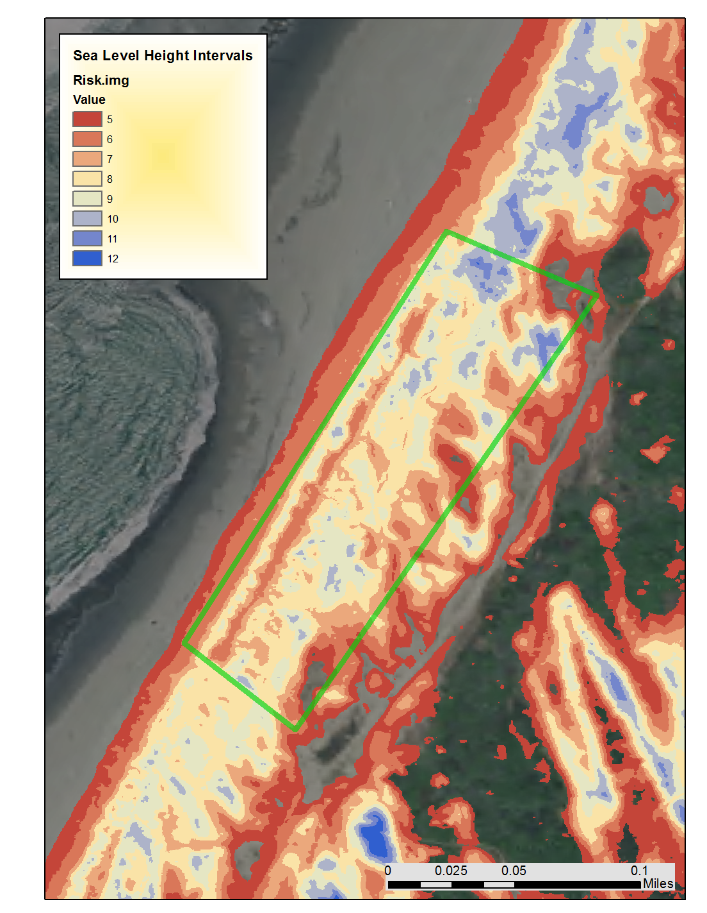
Figure 4: Inundation map if sea level rise occurs
Analysis
The results show two maps, both show different insights into both the impact of sea level on the site and the invasive species composition and cover of the site. It was found that the highest point of the dunes section is 12 meters in height and the lowest of the site is about 4 meters. The legend shows values 5 through 12, which represent the height in meters of inundation of the site area.
Conclusion & Discussion
The data gathered determined the overarching goals of this restoration project:
invasive species treatment to remove the dominate cover type, the grass species Ammophila arenaria and resorting the habitat to be suitable for other native flora and fauna species, especially the Snowy plover. Manual removal would be the suggested treatment, it also allows for very localized impacts that preserve native patches as sources for recolonization of restored areas. Although it’s a labor-intensive process, this method can help eliminate most of the need for revegetation, eventually the plant community will become a mosaic of native grasses and forbs like the two surrounding remnant sites that have been previously restored (Humboldt Bay Dune Restoration, 2015), refer to figure 5 for current image of site and figure 6 for the restoration outcome goals.
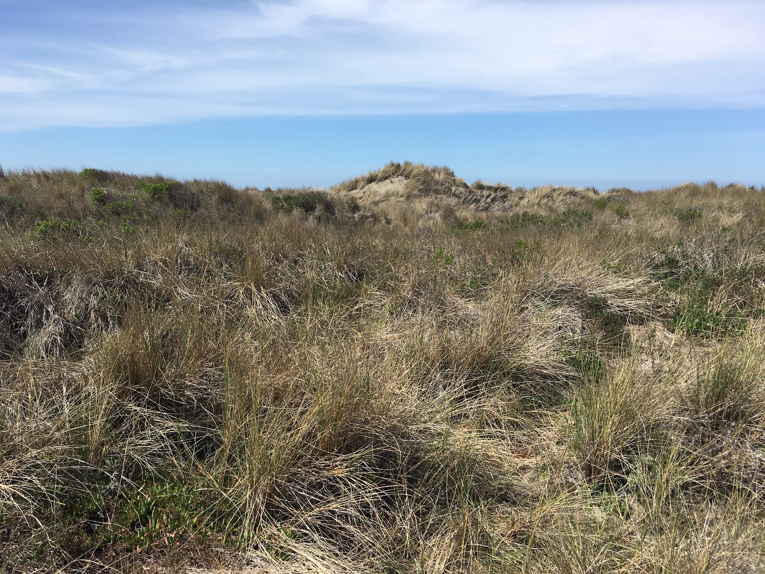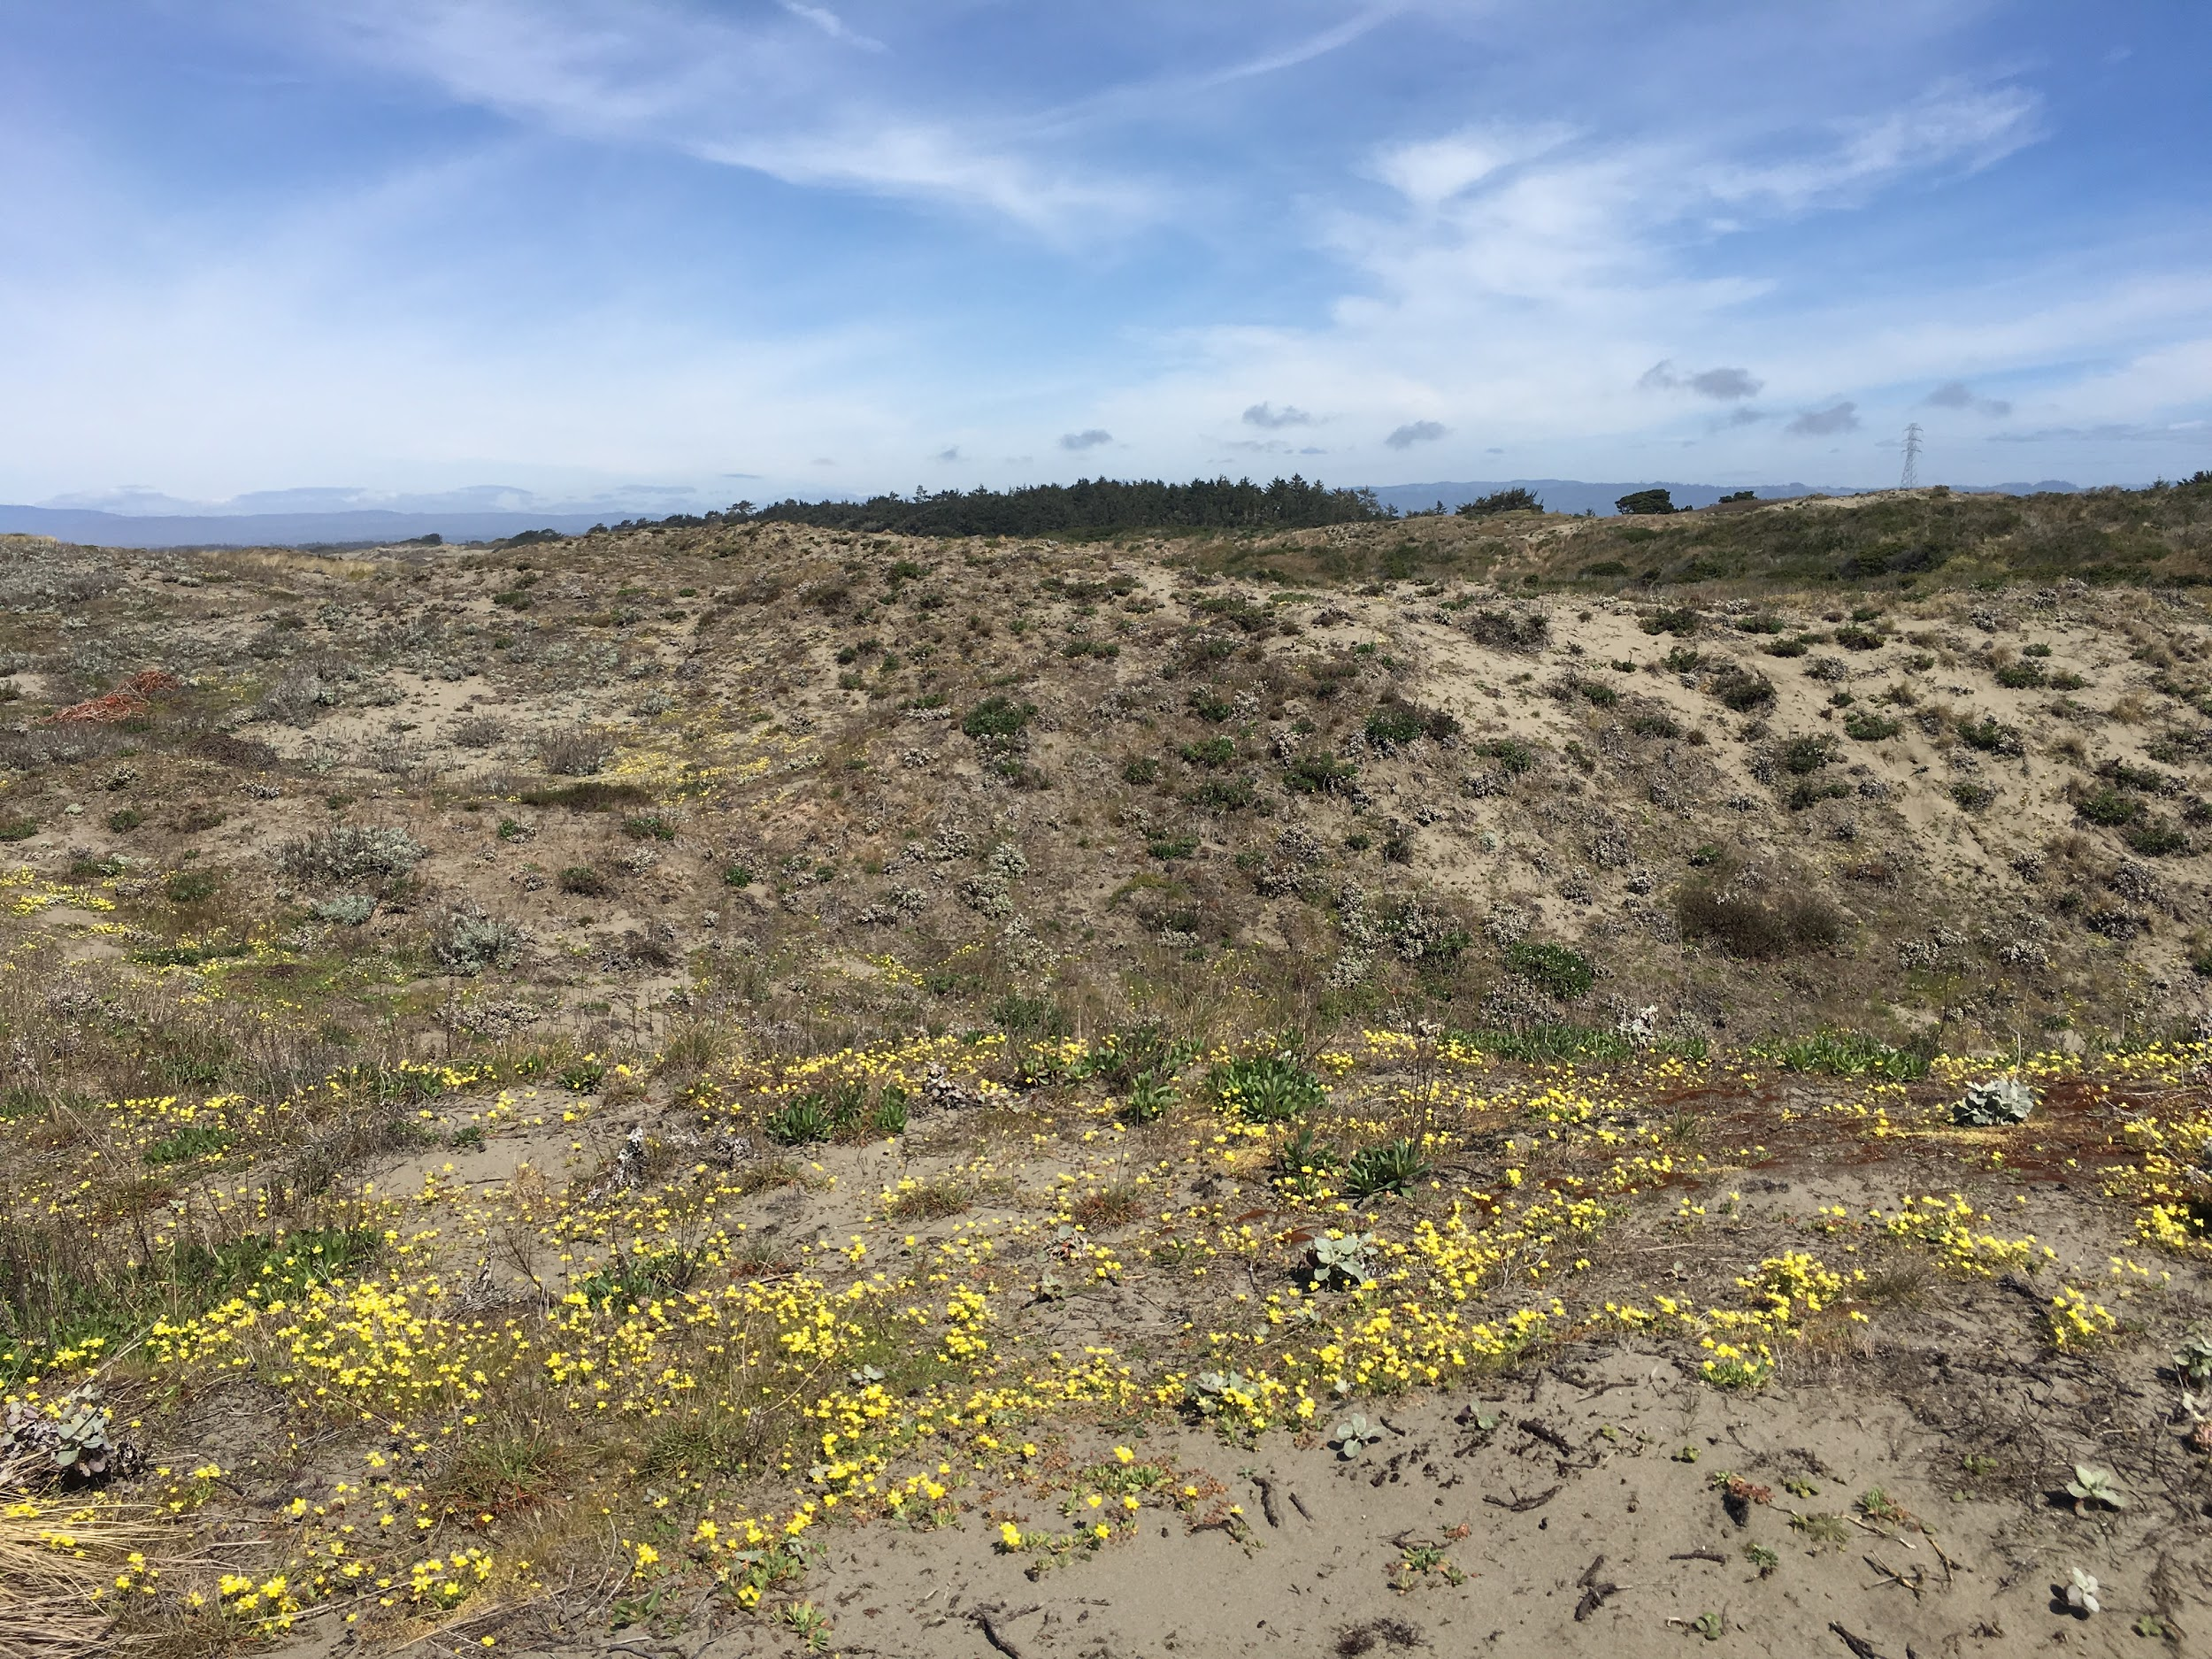
Figure 5: Current cover at the site. Figure 6: Restoration goals
The main concern in the near future is the potential impact of sea level rise on the site. As we found during out spatial analysis, innidation due to sea level rise will affect critical habitat and vegetation, see figure 3. The Snowy Plover is a federally listed species that only lives, breeds and nest in the foredunes which is the most at risk area of the dune ecosystem. If sea level increase only 5 meters, then the windward section of the foredunes would start to erode and become inundated which would result in the Plovers having substantially less hunting ground and the outlook for the survival of that species locally would be grim. If greenhouse emissions are reduced globally there is a potential for a lower rate of sea level rise. Unfortunately, if high levels of greenhouse gas emissions continue, oceans could rise by close to two meters in total by the end of the century, the melting of ice on Antarctica alone could cause seas to rise more than 15 meters by 2500 (DeConto, 2016).

Acknowledgements & References
“Science & Nature.” Friends of the Dunes, www.friendsofthedunes.org/science/restoration.shtml.
“Dune Restoration - Humboldt Bay - U.S. Fish and Wildlife Service.” U.S. Fish & Wildlife
Service, www.fws.gov/refuge/Humboldt_Bay/wildlife_and_habitat/DunesRestoration.htm
“IPCW Plant Report.” California Invasive Plant Council, www.cal-ipc.org/resources/library/publications/ipcw/report5/.
Feagin, Rusty A., et al. “Coastal Erosion, Global Sea‐Level Rise, and the Loss of Sand Dune Plant Habitats.” Frontiers in Ecology and the Environment, Wiley-Blackwell, 1 Sept. 2005, esajournals.onlinelibrary.wiley.com/doi/abs/
DeConto, Robert. “Contribution of Antarctica to Past and Future Sea-Level Rise.”Nature.com, Mar. 2016

