Lab 6 Report: CART

Niko Lopez

March, 7, 2021

Introduction:
In this lab, we explore CART or categorical and regression trees, an intuitive way of creating, and visualizing response predictions based on large sets of covariates. The goal of the present lab is to create a set of models predicting tree genus while changing the control parameters without altering the covariates in order to observe the impact it has on the resulting models.

Methods:
The species were grouped into genus for analysis, rather than the specific species in order to reduce the number of possible responses, making the model easier to interpret, as well as more precise, since species of the same genus may have very similar characteristics. The covariates chosen were taken from the CONUS dataset, which are annual precipitation, annual temperature, temperature range, the minimum temperature during the coldest month, and maximum temperature during the hottest month. I chose three combinations of covariates for modeling and three combinations of control parameters, run along with each of the covariate combinations, resulting in a total of nine models, which can be seen in table 1.
The models were evaluated using the confusionMatrix() function, with accuracy being the main result used in determining the “best” model.

Table 1. The nine models were created, each consisting of three of the five unique covariates. The control parameters (Minsplit, CP) are changed between each
Model # | Covariate 1 | Covariate 2 | Covariate 3 | MinSplit | CP
1 | Annual Precip | Annual Temp | Temp Range | 1000 | 0.01
2 | Annual Precip | Min Temp | Max Temp | 1000 | 0.01
3 | Temp Range | Min Temp | Max Temp | 1000 | 0.01
4 | Annual Precip | Annual Temp | Temp Range | 1000 | 0.005
5 | Annual Precip | Min Temp | Max Temp | 1000 | 0.005
6 | Temp Range | Min Temp | Max Temp | 1000 | 0.005
7 | Annual Precip | Annual Temp | Temp Range | 1000 | 0.001
8 | Annual Precip | Min Temp | Max Temp | 1000 | 0.001
9 | Temp Range | Min Temp | Max Temp | 1000 | 0.001

Results:
The result of the confusionMatrix() function displays the relevant numbers used for model evaluation, which can be seen for every model in table 2. The accuracies of all of the models are below 0.5 but are all fairly close to each other (within 0.05, relative to each other). The model with the greatest accuracy value was model 7, with an accuracy of 0.4958, making it the “best” model out of the nine. Model 7 also had the greatest kappa value and the greatest 95% confidence interval values, further reinforcing the conclusion that it is the “best” model. Curiously, each of the nine models had the same exact P-value of 2.2e-16. The CART tree for model 7 can be seen in figure 1. With the model, a predicted value was made and the resulting map can be seen in figure 2.
Table 2. Confusion matrix results, accuracy being the most important number in evaluating the model.
Model # | Accuracy | 95% CI | Kappa | P-value
1 | 0.4889 | (0.4777, 0.5001) | 0.3491 | 2.2e-16
2 | 0.4862 | (0.475, 0.4974) | 0.3448 | 2.2e-16
3 | 0.4513 | (0.4402, 0.4625) | 0.2993 | 2.2e-16
4 | 0.4929 | (0.4817, 0.5042) | 0.3758 | 2.2e-16
5 | 0.4862 | (0.475, 0.4974) | 0.3448 | 2.2e-16
6 | 0.4566 | (0.4455, 0.4678) | 0.3001 | 2.2e-16
7 | 0.4958 | (0.4846, 0.507) | 0.3677 | 2.2e-16
8 | 0.4928 | (0.4816, 0.504) | 0.3624 | 2.2e-16
9 | 0.4592 | (0.4481, 0.4704) | 0.3128 | 2.2e-16

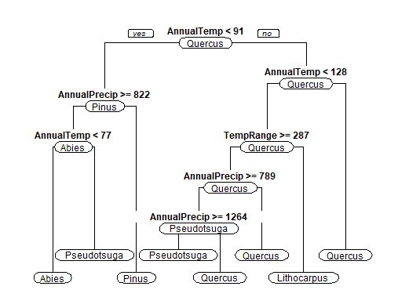
Figure 1. The CART tree of the “best” model, model 7, with the covariates: annual precipitation, annual mean temperature, and annual temperature range, along with the control parameters: minsplit: 100, CP: 0.001
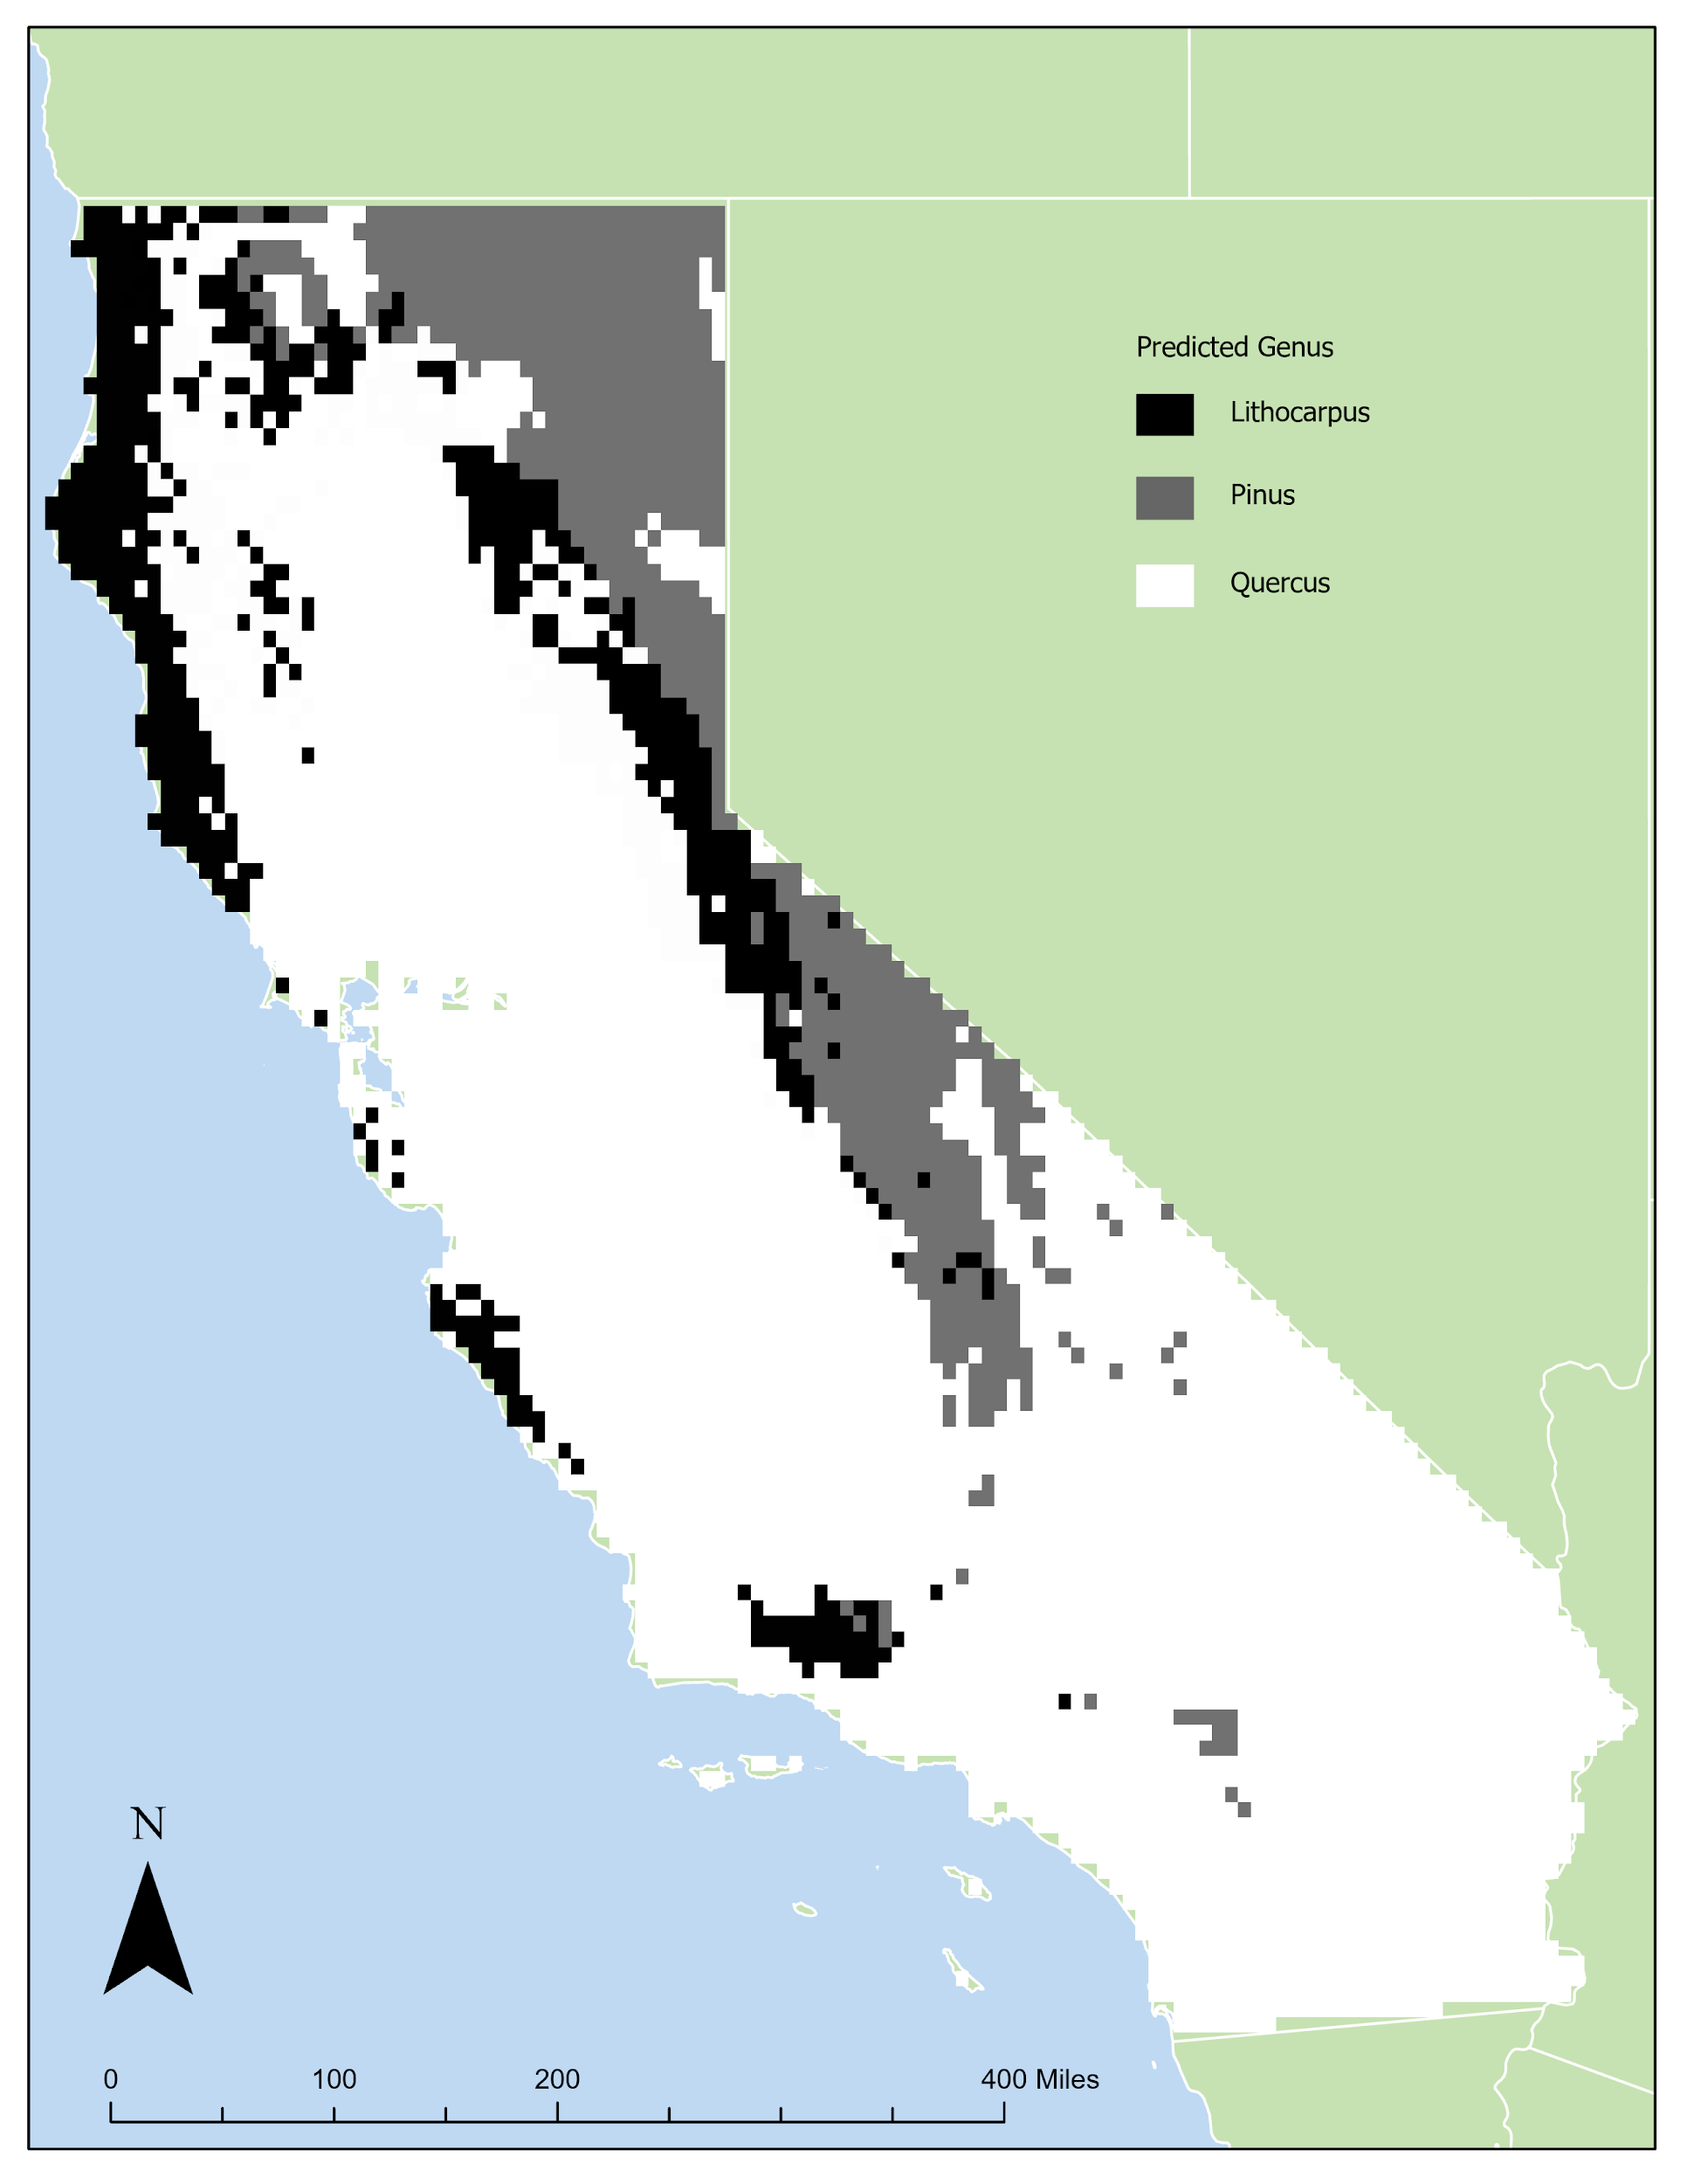
Figure 2. The predicted map surface, derived from model7, the “best” model out of the nine.

Discussion:
I was surprised how close all of the result metrics were between models and different control parameters. The accuracy for every model was within a 0.05 range, and the Kappa was within about 0.07, both of which I would have expected to be wider due to the different covariates. There do not seem to be any tradeoffs in picking any model other than model 7 as the best model. Each resulting metric for model 7 is better than any of the other models. Overall however I do not recommend the model as a reliable predictor for dominant tree genus, because the accuracy should be bigger to be reliable.

Appendix:

R script:

# Import libraries
library(tree)
library(rpart.plot)
library(rpart)
library(caret)
library(e1071)

# Read the data
TheData = read.csv("C:/Users/Niko/Desktop/Lab6/W/Data.csv")

# Remove any NA (null) values
TheData=na.omit(TheData)

##### Model 1

# create the tree with the control object, containing parameters
TheControl1=rpart.control(minsplit=1000,cp=0.01) #create a control object to change the model parameters
TheTree1=rpart(Genus~AnnualPrecip+AnnualTemp+TempRange,data=TheData,method="class",control=TheControl1) # run the model with the parameters

rpart.plot(TheTree1,type=1,extra=0,box.palette=0) # plot the tree

#summary(TheTree1) # print the pruning tree and the details for each node
#printcp(TheTree1) # just print the pruning tree

ThePrediction1 = predict(TheTree1,TheData,type="class") # the type parameter specifies we want a classification (categories) rather than continous

TheResults1=table(ThePrediction1, TheData$Genus) # create the table showing correct and incorrect matches

confusionMatrix(TheResults1) # print the confusion matrix and summary statistics

##### Model 2

# create the tree with the control object, containing parameters
TheControl2=rpart.control(minsplit=1000,cp=0.01) #create a control object to change the model parameters
TheTree2=rpart(Genus~AnnualPrecip+MinTemp+MaxTemp,data=TheData,method="class",control=TheControl2) # run the model with the parameters

rpart.plot(TheTree1,type=1,extra=0,box.palette=0) # plot the tree

#summary(TheTree2) # print the pruning tree and the details for each node
#printcp(TheTree2) # just print the pruning tree

ThePrediction2 = predict(TheTree2,TheData,type="class") # the type parameter specifies we want a classification (categories) rather than continous

TheResults2=table(ThePrediction2, TheData$Genus) # create the table showing correct and incorrect matches

confusionMatrix(TheResults2) # print the confusion matrix and summary statistics

##### Model 3

# create the tree with the control object, containing parameters
TheControl3=rpart.control(minsplit=1000,cp=0.01) #create a control object to change the model parameters
TheTree3=rpart(Genus~TempRange+MinTemp+MaxTemp,data=TheData,method="class",control=TheControl3) # run the model with the parameters

rpart.plot(TheTree3,type=1,extra=0,box.palette=0) # plot the tree

#summary(TheTree3) # print the pruning tree and the details for each node
#printcp(TheTree3) # just print the pruning tree

ThePrediction3 = predict(TheTree3,TheData,type="class") # the type parameter specifies we want a classification (categories) rather than continous

TheResults3=table(ThePrediction3, TheData$Genus) # create the table showing correct and incorrect matches

confusionMatrix(TheResults3) # print the confusion matrix and summary statistics

##### Model 4

# create the tree with the control object, containing parameters
TheControl4=rpart.control(minsplit=1000,cp=0.005) #create a control object to change the model parameters
TheTree4=rpart(Genus~AnnualPrecip+AnnualTemp+TempRange,data=TheData,method="class",control=TheControl4) # run the model with the parameters

rpart.plot(TheTre41,type=1,extra=0,box.palette=0) # plot the tree

#summary(TheTree4) # print the pruning tree and the details for each node
#printcp(TheTree4) # just print the pruning tree

ThePrediction4 = predict(TheTree4,TheData,type="class") # the type parameter specifies we want a classification (categories) rather than continous

TheResults4=table(ThePrediction4, TheData$Genus) # create the table showing correct and incorrect matches

confusionMatrix(TheResults4) # print the confusion matrix and summary statistics

##### Model 5

# create the tree with the control object, containing parameters
TheControl5=rpart.control(minsplit=1000,cp=0.005) #create a control object to change the model parameters
TheTree5=rpart(Genus~AnnualPrecip+MinTemp+MaxTemp,data=TheData,method="class",control=TheControl5) # run the model with the parameters

rpart.plot(TheTree5,type=1,extra=0,box.palette=0) # plot the tree

#summary(TheTree5) # print the pruning tree and the details for each node
#printcp(TheTree5) # just print the pruning tree

ThePrediction5 = predict(TheTree5,TheData,type="class") # the type parameter specifies we want a classification (categories) rather than continous

TheResults5=table(ThePrediction5, TheData$Genus) # create the table showing correct and incorrect matches

confusionMatrix(TheResults5) # print the confusion matrix and summary statistics

##### Model 6

# create the tree with the control object, containing parameters
TheControl6=rpart.control(minsplit=1000,cp=0.005) #create a control object to change the model parameters
TheTree6=rpart(Genus~TempRange+MinTemp+MaxTemp,data=TheData,method="class",control=TheControl6) # run the model with the parameters

rpart.plot(TheTree6,type=1,extra=0,box.palette=0) # plot the tree

#summary(TheTree6) # print the pruning tree and the details for each node
#printcp(TheTree6) # just print the pruning tree

ThePrediction6 = predict(TheTree6,TheData,type="class") # the type parameter specifies we want a classification (categories) rather than continous

TheResults6=table(ThePrediction6, TheData$Genus) # create the table showing correct and incorrect matches

confusionMatrix(TheResults6) # print the confusion matrix and summary statistics

##### Model 7

# create the tree with the control object, containing parameters
TheControl7=rpart.control(minsplit=1000,cp=0.001) #create a control object to change the model parameters
TheTree7=rpart(Genus~AnnualPrecip+AnnualTemp+TempRange,data=TheData,method="class",control=TheControl7) # run the model with the parameters

rpart.plot(TheTree7,type=1,extra=0,box.palette=0) # plot the tree

#summary(TheTree7) # print the pruning tree and the details for each node
#printcp(TheTree7) # just print the pruning tree

ThePrediction7 = predict(TheTree7,TheData,type="class") # the type parameter specifies we want a classification (categories) rather than continous

TheResults7=table(ThePrediction7, TheData$Genus) # create the table showing correct and incorrect matches

confusionMatrix(TheResults7) # print the confusion matrix and summary statistics

##### Model 8

# create the tree with the control object, containing parameters
TheControl8=rpart.control(minsplit=1000,cp=0.001) #create a control object to change the model parameters
TheTree8=rpart(Genus~AnnualPrecip+MinTemp+MaxTemp,data=TheData,method="class",control=TheControl8) # run the model with the parameters

rpart.plot(TheTree8,type=1,extra=0,box.palette=0) # plot the tree

#summary(TheTree8) # print the pruning tree and the details for each node
#printcp(TheTree8) # just print the pruning tree

ThePrediction8 = predict(TheTree8,TheData,type="class") # the type parameter specifies we want a classification (categories) rather than continous

TheResults8=table(ThePrediction8, TheData$Genus) # create the table showing correct and incorrect matches

confusionMatrix(TheResults8) # print the confusion matrix and summary statistics

##### Model 9

# create the tree with the control object, containing parameters
TheControl9=rpart.control(minsplit=1000,cp=0.001) #create a control object to change the model parameters
TheTree9=rpart(Genus~TempRange+MinTemp+MaxTemp,data=TheData,method="class",control=TheControl9) # run the model with the parameters

rpart.plot(TheTree9,type=1,extra=0,box.palette=0) # plot the tree

#summary(TheTree9) # print the pruning tree and the details for each node
#printcp(TheTree9) # just print the pruning tree

ThePrediction9 = predict(TheTree9,TheData,type="class") # the type parameter specifies we want a classification (categories) rather than continous

TheResults9=table(ThePrediction9, TheData$Genus) # create the table showing correct and incorrect matches

confusionMatrix(TheResults9) # print the confusion matrix and summary statistics

##### Create the predicted surface

# Read the data
NewData = read.csv("C:/Users/Niko/Desktop/Lab6/W/NewData.csv")

# Remove any NA (null) values
NewData=na.omit(NewData)

ThePrediction = predict(TheTree7,NewData,type="class")

FinalData=data.frame(NewData,ThePrediction)
write.csv(FinalData, file = "C:/Users/Niko/Desktop/Lab6/F/Fin.csv")

AsNumbers=as.numeric(as.factor(ThePrediction))
FinalData=data.frame(NewData,AsNumbers,ThePrediction)
write.csv(FinalData, file = "C:/Users/Niko/Desktop/Lab6/F/Fin.csv")

