HSU Campus Informational Map Beta (1.0) Release

Web Map

Nikolas Lopez
December 1, 2021
GSP 410

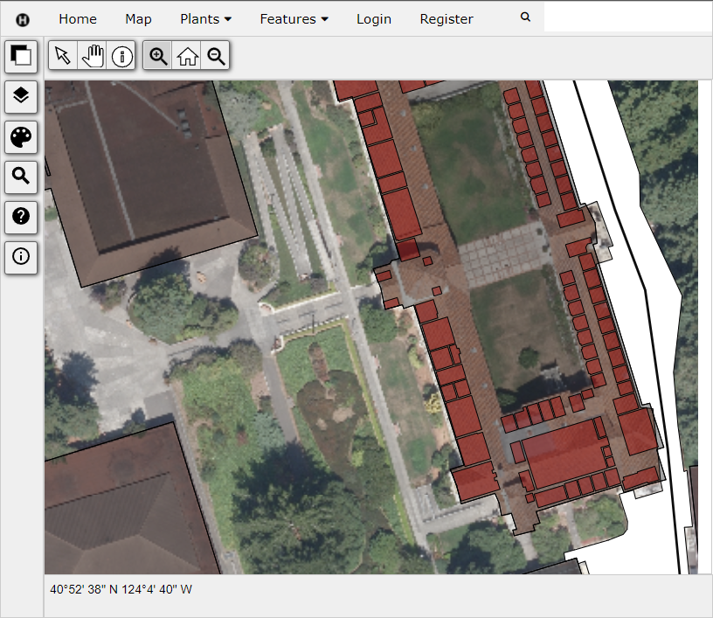

Introduction

Development of the HSU Campus Informational Map was initiated by Dr. James Graham as a replacement for the existing HSU Campus Map, created by students during a previous semester. The old map had a number of issues including slow loading times and limited capability due to being file based as opposed to storing data on a relational database. This new campus map utilizes the versatile web mapping solution developed by Dr. Graham called CanvasMap which solves many of the problems found in the previous map, and allows for greater flexibility. The spatial data gathered and digitized for the old HSU Campus Map, such as buildings, transportation, parking, etc., is included in this new map.
In fall 2021, Niko Lopez began working on the HSU Campus Informational Map, working alongside Dr. Graham to add data, manage the database, and improve the web map. Niko’s primary goal for this semester was to begin the process of digitizing rooms on campus with the vision of making this data accessible to students to aid them in better navigating campus.
With HSU’s pivot towards being a polytechnic university, students should have an accessible campus web map solution available to them, providing a rich source of valuable spatial information about resources on campus. The overall purpose of the HSU Campus Informational Map is to serve as an accessible, and scalable platform to provide relevant GIS information to HSU students, staff and guests.

Methods

Floor digitization
To begin digitizing rooms, a list of floor plans was selected for digitization. Floors with classrooms and labs were prioritized, followed by office spaces and others. In the future Digitization of some facilities such as the library will require customized digitization which will be done in coordination with the staff in the appropriate department. Floor plans were accessed through the HSU FacilitiesLink portal with authorization. PDFs were downloaded from FacilitiesLink, screenshotted, and saved as a PNG for georeferencing in ArcGIS Pro. PNGs were georeferenced by aligning the edges of the floorplans with the corresponding polygon in the buildings layer using scaling, rotating and moving, or just using control points.
Unique shapefiles were created for each individual floor plan, containing multiple room polygons. The name of each shapefile is named based on the floors building code and floor number as seen on the facilities link portal “FH_G, HGH_2, etc”. A text field named RoomNum was added to the attribute table of each layer that contains the room number for each polygon as seen on the floorplan. Each room that has a unique room number on the floor plan is digitized with a single polygon.

Inserting floors into the database
The naming of both the text field name “RoomNum” and file name “FH_G, HGH_2, etc” for each shapefile was essential for easy insertion into the database. Once the naming was in order, shapefiles were ready to be inserted into the database. To insert the floors into the database they had to be placed into a set folder structure. In the GIS-teaching server there is a folder (C:\Projects\ProjectsPython\2021 HSU Map\Rooms) that contains all of the room data sorted by buildings using the respective building code as folder names. Any future room data should be placed in the folder using the same structure convention, otherwise the data will not be properly inserted into the database.
After the two previous conditions were met, naming conventions and folder structure, all that was left to do was to run a python script located on the gis-teaching server (C:\Projects\ProjectsPython\2021 HSU Map\InsertFloors.py) to insert the data into the database.
To put the floors in the correct order on the building floor legend, which appears in the upper right hand corner of the web map when you select a building, changes were made to the building_floors table in the PostgreSQL database. The field that was changed was order_number, which is numbered in the opposite order as the floor numbers, with the top floor being 1, and so on. This is demonstrated in figure 1.

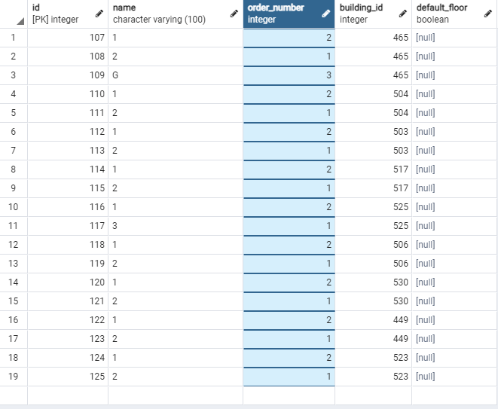
Figure 1. The database building_floors table. The order_number column is highlighted. Notice the opposite order of the order number compared to the name column.

Digitization Lab
To expand upon the room dataset going forward, digitization labs will be held using the provided instructions and materials. A spreadsheet was created to streamline the digitization process, outlining the digitization status of each floor, its Building code, Final Name, digitizer name and date, and QAQCer name and date. This spreadsheet should be expanded to include additional floors as the floors selected for digitization are completed.

HSU Room Digitization Project File
In order to aid in the digitization process and provide examples of good georeferencing and digitization, the provided HSU Room Digitization ArcGIS Pro project was developed to be used in labs. This folder contains a number of georeferenced and not georeferenced floor plans and every room shapefile created up until this point. It also contains the buildings polygon layer and a clipped Imagery raster of the HSU Campus.

Student and Faculty Survey
A survey was conducted to gauge the interest and technical needs of students, alumni and staff for using the HSU campus map. The survey contains a variety of questions relating to desired spatial features for the map as well as the respondents preferred device and browser to use in accessing the web map. This information should be used to update the spatial datasets, search terms and supported platforms on the web map going forward.

Results

Current Web Map
The HSU Campus Informational Map is currently published on the Internet with all of the current room data and other spatial data retrieved from the previous HSU Campus Map. To access the room data on the web map, click on any building that has room data (ex. Founders Hall, Forestry, Natural Resources) and click on the desired floor number in the legend which appears in the upper right corner of the map view.

Student/faculty survey
We received 13 responses to the survey from students, alumni and faculty, most of which were students (69%) (Figure 2). The prefered browser of the survey respondents was google chrome (69%) followed by safari (23%), and edge (7.7%)(Figure 3). Ranging from very unlikely (1) to very likely (5), the mean interest in using the web map was 4.2 (Figure 4). The mean interest in the capability to access room locations on the web map through Google Calendar was 4.2 (Figure 5). The prefered devices for using the web map were 50% smartphones, and 50% computers (Figure 6). Apple smartphones were prefered by 11 respondents, while Android smartphones were prefered by 3 respondents. Desktops were prefered by 7 respondents and laptops were preferred by 7 respondents. At least one respondent selected both Android and Apple smartphones and desktop and laptop computers since the total responses in both the smartphone and computer categories exceeds the total number of respondents
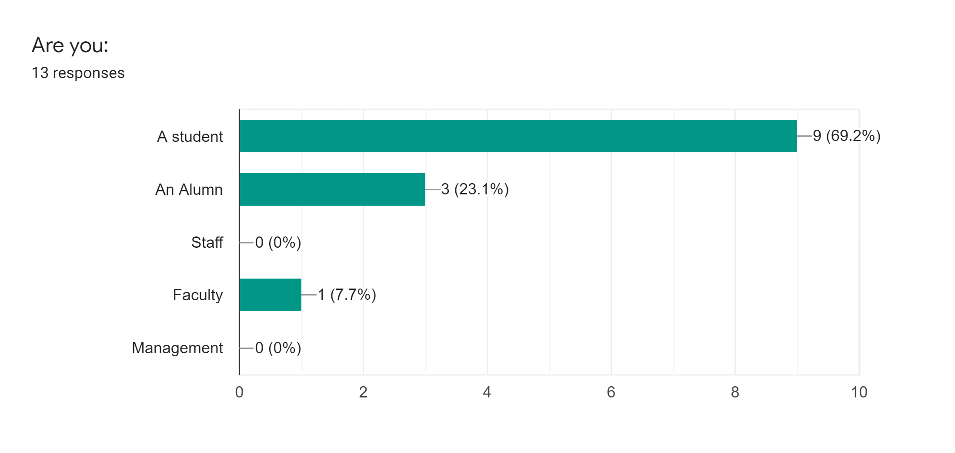
Figure 2. The demographics of the survey respondents.
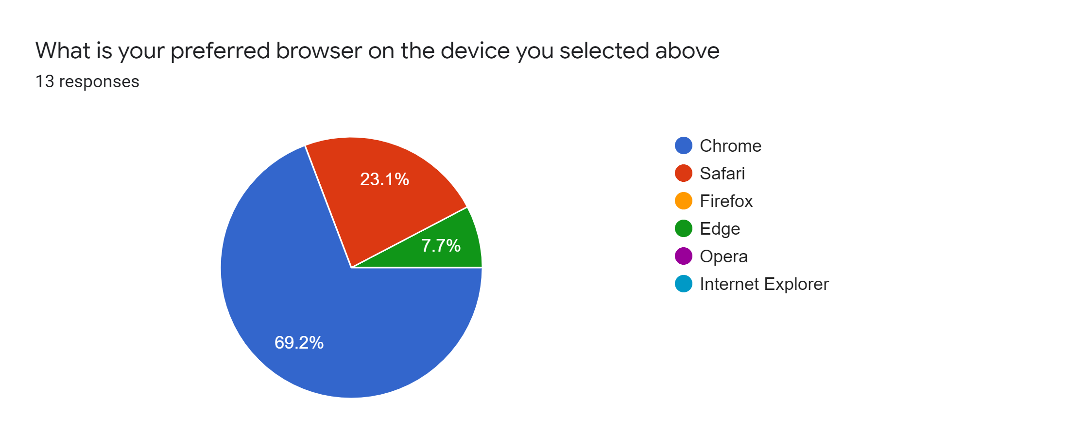
Figure 3. The prefered web browser of survey respondents.
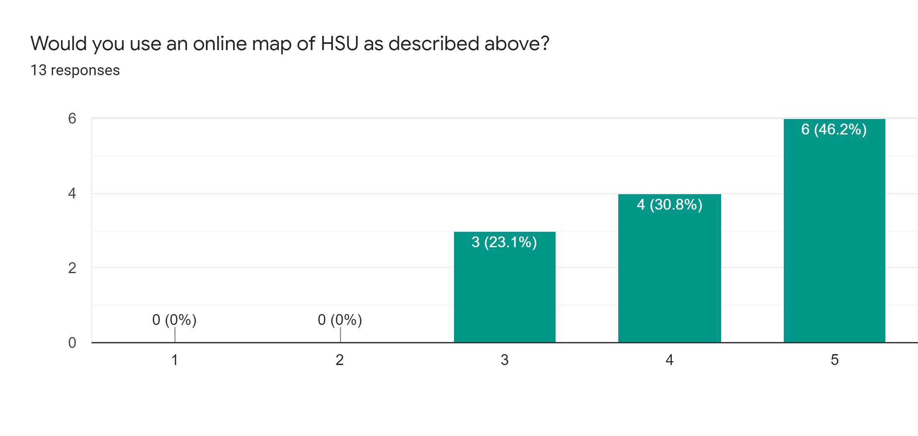
Figure 4. The interest in using the HSU Campus Informational Map. (Mean = 4.2)
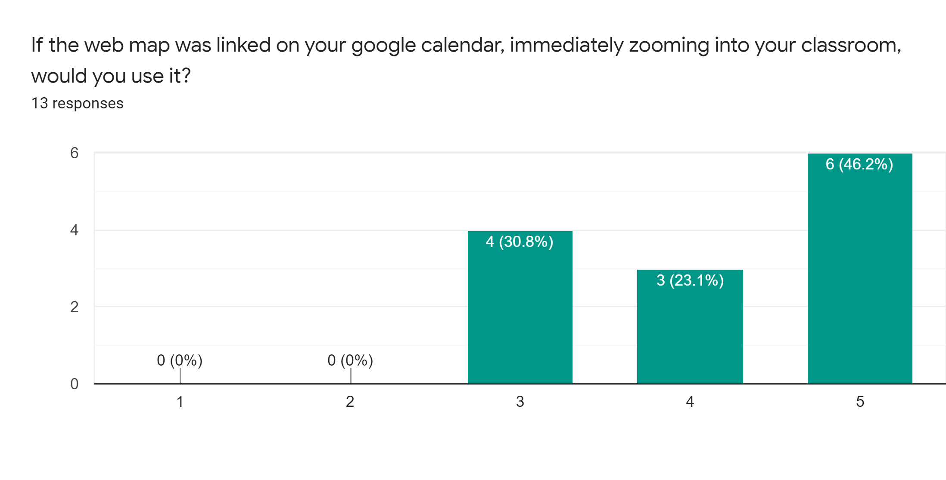
Figure 5. The interest in the ability of finding classroom locations from google calendar. (Mean = 4.2)
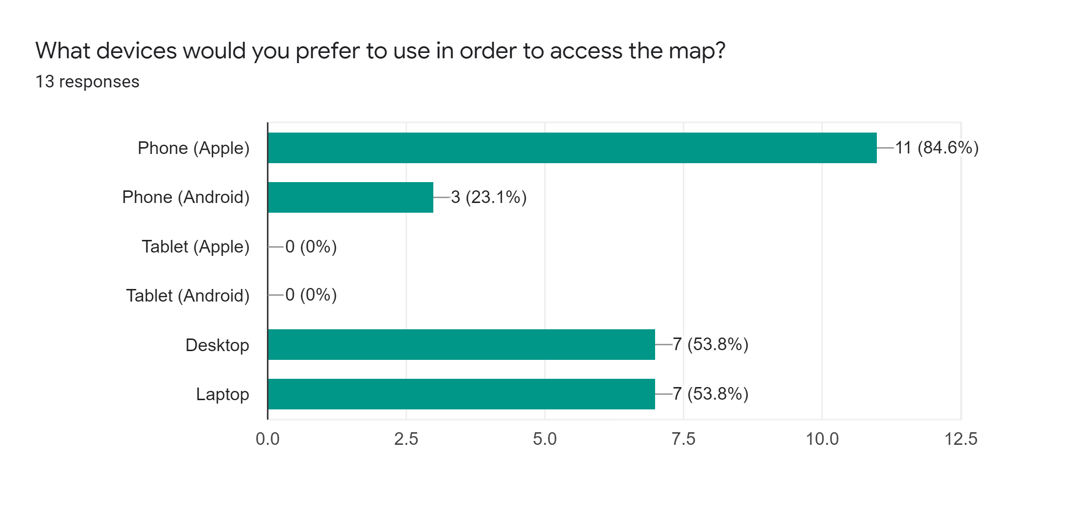
Figure 6. Prefered devices of survey respondents. Some respondents selected multiple options.

Next Steps

Get More Responses and Improve the Survey
To get a better understanding of the needs of the intended audience, more input should be gathered from the student body and HSU staff. A new survey should be created by students in a future semester with the provided survey as a guide to improve upon. Creating the survey and subsequently gathering responses should be prioritized early in the semester, enabling the group to have time to act on the results.

Fix mobile phone support issues
There are a few issues with accessing the web map on mobile devices which should be resolved before the webmap can be used. Some mobile issues that are not listed here may still exist and more may arise as new features are added to the web map, so further testing across multiple devices is required in the future.

- On android, the building floor level legend does not work on google chrome, firefox, or the samsung internet browser.
- On android, the expandable menu is not functioning properly on google chrome, but works on firefox and the samsung internet browser.

Additional digitization
Further digitization is required to complete the room dataset and other new datasets. Digitization of the room dataset should be done in GSP labs using the provided HSU Room Digitization ArcGIS Pro project file. There are a number of georeferenced and not georeferenced floor plans currently in the project which should be prioritized, however after they have been completed, additional floors should be added to the list.
Building entrances and stairs should be digitized for each building. When any room polygons are loaded on the web map, the entrance and or stairs layers for that level should be loaded as well.

Potential Future Features
There are a number of features which have been proposed, but not yet implemented in the HSU Campus Informational Map. These features include:

- Least cost path - There has been great interest in an easy to use tool to determine the lowest change in elevation, and least distance path in between two points on campus.
- Acces from google calendar - There is interest in adding links to web maps, highlighting classroom locations, onto the class google calendar for students to easily utilize the room dataset that will be growing over time.
- Adding lab availability times - There was expressed interest in the survey in the ability to see live lab availability times. This should be looked into in the future in cooperation with the HSU administration department that manages class scheduling. -add link to its schedule page.

Formal Web Map Testing
In order to discover any issues or bugs existing in the web map, formal testing should be conducted across multiple devices and browsers. Every action available to the end user should be tested on each browser with each device. IOS and Android phones as well as Mac OS and Windows computers should be tested using Chrome, Safari, Firefox and Edge.

The following web map functions should be tested across all devices and browsers:
- Select a building. (Use the select tool.)
- Pan around on the canvas. (Use the hand tool.)
- Navigate the layers list and load layers to the map.
- Select a building and display a floor polygon (Founders hall for example) from the floor legend that is displayed on the top right corner of the map canvas.

Add formal testing

